COVER NO: 1

REF: 141/ET/MECL/MM/CONT/CGH/03 DATED: 20/06/2026

To:
GM/HOD (Procurement and Contract)
Mineral Exploration and Consultancy Limited,
Dr. Babasaheb Ambedkar Bhawan, Seminary Hills,
NAGPUR-440006 (Maharashtra) INDIA.

SUBJECT | Submission of EMD or Copy of Udyam certificate

REFERNCE: | 144/ET/MECL/MM/CONT/CGH/04
With reference to the tender under reference we would like to participate in the bid on-line. As per the instruction given in bid documents, we are forwarding herewith the prescribed EMD as detailed below off-line. Copy of this letter along with Demand Draft as detailed below will also be uploaded on the CPPP-NIC in the appropriate cover along with duly filled bid documents to enable you to open our bid.
DETAILS OF EMD SUBMITTED
1 | Amount of EMD as per NIT Submitted: | Rs. -
1 | Demand Draft No. | Rs. -
1 | DD Date | -
1 | DD Valid up to | -
1 | DD amount | Rs.-
1 | DD drawn on (Name of Bank) | -
2 | NEFT/RTGS (Date and UTR No.) For EMD: | -

As we are registered Udyam bidder for the product we have quoted, we may please be exempted from submission of Earnest Money Deposit (EMD). Copy of UDYAM certificate, is forwarded herewith as instructed in the bid. Copy of the same is also be uploaded on the CPPP-NIC in the appropriate cover.


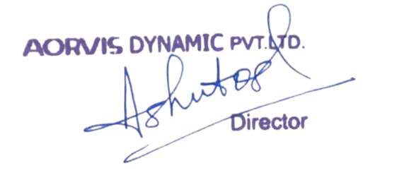
DETAILS OF UDYAM CERTIFICATE
1 | Registered Udyam firms | District Industries Centre
2 | Registration Certificate No. & Date | UDYAM-AS-03-0046614 ; 30/05/2024
3 | Registration Certificate valid up to | 2026-2027
We hereby certify that the offered/quoted product against your bid under reference is covered under above registration (List of items attached) and entitled for EMD exemption.

